**Tables**

**Table 1:** Modeled effects of time (t) and position within the watershed (P) [*revise now with fetch, so the model is: space*time + fetch*] on plot-scale diversity estimates of invertebrate assemblages. Model comparisons for mixed effects models with meadow as a random effect. AICc, AIC weight (*w*) and δAIC values, and results of likelihood ratio tests (P-values) that compare the model in one row with model Basic 1 (first row). The best model has the lowest AICc value, and likelihood ratio tests facilitate interpretation of differences in models with similar AICc values (* P < 0.05 for a comparison of the best model with other models in the set)

*Add in grazers as additional rows? Re-analyze this, maybe just for july all 9?*

|  |  |  |  |  |  |  |  |  |
| --- | --- | --- | --- | --- | --- | --- | --- | --- |
| **Model** | | ***w*** | **df** | **logLik** | δAIC | Time | Pos | T*P |
| **Ln(Abundance)** | |  |  |  |  |  |  |  |
| **A3\*** | **ln(N) = t + P + t*P** | **0.824** | **8** | **-90.05** | **0.00** | 0.03  [-0.06, 0.11] | -0.01  [-0.04, 0.01] | **0.02**  [0.01, 0.02] |
| A1 | ln(N) = t | 0.115 | 6 | -94.15 | 3.93 |  |  |  |
| A2 | ln(N) = t + P | 0.060 | 7 | -93.74 | 5.23 |  |  |  |
| Rarified Richness | |  |  |  |  |  |  |  |
| **B2\*** | **RR = t + P** | **0.569** | **7** | **-726.32** | **0** | **1.42**  [0.34, 2.50] | 0.04  [-0.15, 0.24] | 0.00  [-0.12, 0.13] |
| B1 | RR = t | 0.232 | 4 | -730.37 | 1.79 |  |  |  |
| B3 | RR = t + P + t*P | 0.198 | 8 | -726.30 | 2.11 |  |  |  |
| Simpson’s Index | |  |  |  |  |  |  |  |
| **C2\*** | **SI = t + P + t*P** | **0.687** | **8** | **85.42** | **0** | **0.08**  [0.03, 0.12] | 0.01  [-0.01, 0.02] | 0.00  [-0.01, 0.00] |
| C1 | SI = t | 0.160 | 6 | 81.83 | 2.92 |  |  |  |
| C3 | SI = t + P | 0.153 | 7 | 82.85 | 3.01 |  |  |  |

**Figures**

**Figure 1**: Eelgrass meadows sampled during summer 2012 between Alberni Inlet (red star) and the Pacific Ocean southwest of Dodger Channel (DC). Five meadows were sampled in May, July and August (red dots), while four additional meadows were sampled once in midsummer (yellow dots).   WI = Wizard Islet, BE = Bald Eagle Cove, EI = Ellis Island, RP = Robber’s Passage, NB = Numukamis Bay, CB = Crickett Bay, BI = Boyson Islands, CC = Crow Cove. BMSC = Bamfield Marine Sciences Centre.

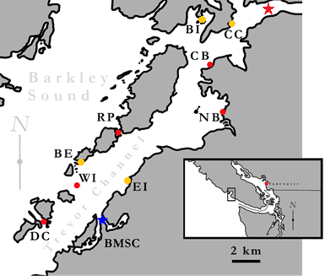

**Figure 2**: [placeholder for when final fetch estimates come in]. this figure shows increases in the abundance of grazer taxa with increasing site exposure (C ) relative to filter feeders (A), driven partly by total increases in abundance (B), and not by trends in filter feeders. The pattern was not present in May, before recruitment of filter feeders, phyllaplesia and population increases in some grazers. The pattern is also less clear in August when grazers at NB had dropped, but it’s hard to say without final fetch values.



Figure 3. Checkerboard metacommunity structure.



**Figure 4:** Dispersion of multivariate community for each site and sample period using the Bray-Curtis dissimilarity index (Appendix 4). Red filled points represent average median value observed in null model analyses.

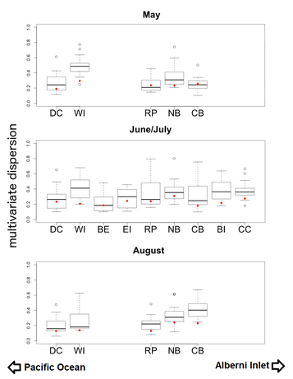

**Figure 5:** Nonmetric Multidimensional Scaling (NMDS) plot visualizing community composition across all sites and times. Polygons represent multivariate communities for each meadow at one time (n = 16 samples per meadow). Polygon area is representative of observed within-meadow beta diversity, such that a larger polygon indicates greater beta diversity among the plots sampled from that meadow. Overlap of polygons indicates similar species composition and relative abundance from plots sampled within different meadows. First two letters of polygon labels are the site codes, given in Table 1 and Figure 1, and the third letter indicates the time period sampled (A = May, C = July, and E = August).